Contents

Internship Batch Details: 2

Product Vision 4

User Story Workshop 7

Adding BV and CP to User stories 10

Product Backlog 11

Sprint Understanding 11

Sprint 1 15

Scrum 1 16

Scrum 2 15

Scrum 3………………………………………………………………………………………………………………………………………………….16

Sprint 1 – Closing Activities 18

Sprint Retrospective meeting: 18

Sprint Review meeting: 18

Sprint Velocity 19

Sprint Burn Down Chart 19

Sprint Burnup Chart 19

Product insights for improvement 20

Team Experiences with Sprint 1 20

Scrum Master 20

Product Owner 20

Scrum Developer 20

Process Observations 20

# Internship Batch Details:

**Batch No:** 10:30 AM

**Batch Date:** July 6th, 2020

Location: Online

Scrum Faculty Names: A. Dhileep Kumar

Batch participants:

1. Ancila Pulipaka
2. Naveen Kumar
3. Pratyusha Allam
4. Satish Kumar
5. Surabhi Srivastav
6. Shrey Kankaria
7. Shashi Kumar

**Date of Start:** August 24th, 2020

**Scrum Project Name:** Asgard Stores

**Scrum Project Description**: Asgard Stores is a one-stop-online shopping solution, which provides access to diverse categories of products at customer convenience. The solution also helps the sellers to reach and serve a bigger customer base which was not possible earlier due to geographical limitation.

# Product Vision

– Meeting – Discussion – Document -

**Scrum Project Name: Asgard Stores**

**Venue:** Online

**Date:** August 24th,2020 **Start Time**: 10:30 AM **End Time**: 18:30 PM **Duration**: 8 Hours

**Client:** A. Dhileep Kumar

**Stakeholder List:** 1. Customer 2. Seller 3. Admin 4. Logistics 5. Customer Support Management (CSM)

**Scrum Team** Scrum Master : Satish Tandley Product Owner : Naveen Kumar Scrum Developer 1 : Shrey Kankaria Scrum Developer 2 : Shashi Kumar Scrum Developer 3 : Ancila Pulipaka Scrum Developer 4 : Surabhi Shrivastav Scrum Developer 5 : Pratyusha Allam

| **Vision- To excel in the Indian E-commerce sector and establish as the most reputed brand by the year 2025** | | | |
| --- | --- | --- | --- |
| **Target Group** | **Needs** | **Product** | **Value** |
| All general audience who wants to sell and purchase products online | Improve the convenience of customer and expand the purchasing horizon. | Our product is a one-stop-online shopping solution, which provides access to diverse categories of products at customer convenience. The solution also helps the sellers to reach and serve a bigger customer base which was not possible earlier due to geographical limitation. | Business goal: To make a valuable impact on the Indian e-commerce industry and transform the market with the advancements in software solutions and logistics management.  Benefit:  1.High quality products at competitive prices  2.Wider range of products at one place  3. Compare and buy products at free will.  4. Flexible payment options.  5. A virtual selling platform open for everyone.  6. Start selling with low investment.  7. No need to maintain huge inventory.  Business Model:  1. Provide one stop shop for wide variety of products used by different spectrum of consumer.  2. Enable small scale and local buyers to sell their products to wider markets.  3. Enable suppliers to sell their products to wider markets.  4. Provide high quality products at competitive prices. |
|  |  |  |  |

**User Story Workshop**

**Scrum Project Name:** Asgard Stores

**Venue:** Online

**Date:** August 24 & 25, 2020 Duration: 8 Hours

**Participant List:** 1. Ancila Pulipaka

2. Naveen Kumar

3. Pratyusha Allam

4. Satish Kumar

5. Surabhi Srivastav

6. Shrey Kankaria

7. Shashi Kumar

**User Stories Division and Distribution**

**Sections (Epics) Identified:**

**I. Customer Module: 7 Epics: 30 User Stories**

Profile Management

Product Catalog Management

Wish list Management

Suggestions/Recommendations

Order/Cart Management

Payment Management

Order Tracking

**II. Seller Module: 4 Epics: 12 User Stories**

Profile Management

Products Approvals

Order Refunds/Replacements

Order Tracking

**III. Admin-1 Module: 4 Epics: 7 User Stories**

Profile Management

Seller Approvals

Seller Product Approvals

Seller Account Management

**IV. Admin-2 Module: 5 Epics: 7 User Stories**

Revenue Management

Products Review tracking

Order Tracking

Offer & Deals

Control Spam

**V. Customer Support-1 Module: 3 Epics: 14 User Stories**

Service Tickets Handling

Products Catalog FAQ's

Payment transactions

**VI. Customer Support-2 Module: 3 Epics: 13 User Stories**

Order Management

Customer Profile

Offers & Deals

**VII. Logistics: 5 Epics: 9 User Stories**

Logistic Vendor Management

Delivery Personal tracking

Product Tracking

COD/POD Payment Management

Product Inspection and Returns

**Participant and Section Allotted**

1. Pratyusha Allam- Customer Module

2. Naveen Kumar- Seller Module

3. Ancila Preti- Admin Module

4. Satish- Admin Module

5. Shashi Kumar- Logistics Module

6. Surabhi Srivastav- Customer Support Module

7. Shrey Kankaria- Customer Support Module

**Total user stories written** – count- 92

**Finalized user stories –** count- 92

I. Customer Module: 7 Epics: 30 User Stories

II. Seller Module: 4 Epics: 12 User Stories

III. Admin-1 Module: 4 Epics: 7 User Stories

IV. Admin-2 Module: 5 Epics: 7 User Stories

V. Customer Support-1 Module: 3 Epics: 14 User Stories

VI. Customer Support-2 Module: 3 Epics: 14 User Stories

VII. Logistics: 5 Epics: 9 User Stories

**Total user stories BV added** – count of User stories -> 92 BV Total Value--> **24600**

**Total user stories CP added** – count of User stories -> 92 CP Total Value--> 284

**Prioritization Technique to use:** MoSCoW

# Product Backlog **updated in jira**

**MVP**: ASG_C_005, ASG_C_006, ASG_C_007, ASG_C_009, ASG_C_008, ASG_S_001, ASG_S_002, ASG_S_006, ASG_S_011, ASG_AD_001, ASG_AD_006, ASG_AD_009, ASG_C1_13, ASG_AD_005, ASG_L_001, ASG_L_002, ASG_L_003, ASG_L_004,

**Must:** ASG_C_001, ASG_C_002, ASG_C_003, ASG_C_024, ASG_C_025, ASG_C_026, ASG_C_027, ASG_C_018, ASG_C_019, ASG_C_020, ASG_C_021, ASG_C_022, ASG_C_023, ASG_C_030, ASG_AD_020, ASG_AD_021, ASG_AD_017, ASG_AD_022, ASG_S_005, ASG_C2_01, ASG_S_009, ASG_S_010, ASG_L_006, ASG_L_007, ASG_L_008, ASG_L_009, ASG_C2_02, ASG_C2_03, ASG_C1_01, ASG_C1_02, ASG_C1_03, ASG_C1_04, ASG_C1_05, ASG_C1_06, ASG_C1_07, ASG_C1_08, ASG_C1_09, ASG_C1_10, ASG_C1_11, ASG_C1_12, ASG_C1_14

**Should:** ASG_C_010, ASG_C_011, ASG_C_012, ASG_C_013, ASG_C_014, ASG_C_015, ASG_C_028, ASG_C_029, ASG_AD_002, ASG_AD_008, ASG_AD_019, ASG_AD_013, ASG_S_003, ASG_S_011, ASG_S_013, ASG_C2_04, ASG_C2_05, ASG_C2_06, ASG_C2_07, ASG_C2_08, ASG_C2_09, ASG_C2_10, ASG_C2_11,, ASG_C2_12

**Could:** ASG_C_004, ASG_C_016, ASG_C_017, ASG_AD_023, ASG_AD_024, ASG_S_004, ASG_S_012, ASG_C2_12

**Would/Won’t:** ASG_L_005

# Sprint Understanding

Sprint Duration: 3 Hours

Sprint Value 61

Scrum Duration: 1 Hour

# Sprint 1

Start Time: 4PM End Time: 7PM Duration: 3 Hours 40 minutes

Sprint Planning Meeting: 11AM

| **Participants:**   1. Ancila Pulipaka 2. Naveen Kumar 3. Pratyusha Allam 4. Satish Kumar 5. Surabhi Srivastav 6. Shrey Kankaria 7. Shashi Kumar |
| --- |
| **Discussion Points:**   1. 18 User stories have been selected from MVP. 2. User stories are equally shared among the team members. 3. Team members will pitch in if any member cannot collaborate. 4. Team would note down areas of improvement observed. 5. Team should forecast and intimate impediments ASAP to Scrum master. 6. Team would provide story points with a buffer of 20% included. |
| **User Stories Selected :**  ASG_C_005  ASG_C_006  ASG_C_007  ASG_C_009  ASG_C_008  ASG_S_001  ASG_S_002  ASG_S_006  ASG_S_011  ASG_AD_001  ASG_AD_006  ASG_AD_009  ASG_C1_13  ASG_AD_005  ASG_L_001  ASG_L_002  ASG_L_003  ASG_L_004 |

Sprint Backlog- **UPDATED IN JIRA**

# **Scrum 1**

Start Time: 5:00 End Time: 5:03 Duration: 2-3 minutes

| **Participant** | **Task** |
| --- | --- |
| Ancila Pulipaka | ASG_S_001  ASG_S_002  ASG_S_011  ASG_AD_001 |
| Naveen Kumar | ASG_AD_005  ASG_AD_006  ASG_AD_009  ASG_S_006 |
| Pratyusha Allam | ASG_C_005  ASG_C_006  ASG_C_007  ASG_C_009 |
| Satish Kumar | ASG_L_002  ASG_L_003  ASG_L_004 |
| Surabhi Srivastav | ASG_C1_013 |
| Shrey Kankaria | ASG_C_008 |
| Shashi Kumar | ASG_L_001 |

Scrum Meeting :

| **Participant** | **Scrum Meeting points** |
| --- | --- |
| Ancila Pulipaka | Done with ASG_S_001 and ASG_S_002  Will work on ASG_S_011 and finish it by next scrum |
| Naveen Kumar | Done with ASG_AD_005  Will work on ASG_AD_006 and finish it by next scrum |
| Pratyusha Allam | Done with ASG_C_005  Will work on ASG_C_006, ASG_C_007 and finish them by next scrum |
| Satish Kumar | Done with ASG_L_002  Will work on ASG_L_003 |
| Surabhi Srivastav | Absent for the standup |
| Shrey Kankaria | Absent for the standup |
| Shashi Kumar | Absent for the standup |

**Impediments Log:**

Naveen Kumar - Started working on Balsamiq before starting the sprint in Jira

Pratyusha Allam - Moved the userstory to done in jira before starting the sprint

Initially the userstory could not be accessed, hence it was flagged

# **Scrum 2**

Start Time: 6PM End Time: 6:05 Duration: 5 Minutes

Participant and Task Selected

| **Participant** | **Task** |
| --- | --- |
| Ancila Pulipaka | ASG_S_011  ASG_AD_001 |
| Naveen Kumar | ASG_AD_006  ASG_AD_009  ASG_S_006 |
| Pratyusha Allam | ASG_C_006  ASG_C_007  ASG_C_009 |
| Satish Kumar | ASG_L_003  ASG_L_004 |
| Surabhi Srivastav | ASG_C1_013 |
| Shrey Kankaria | ASG_C_008 |
| Shashi Kumar | ASG_L_001 |

| **Participant** | **Scrum Meeting points** |
| --- | --- |
| Ancila Pulipaka | Done with ASG_S_011  Will work on ASG_AD_001 and finish it by next scrum |
| Naveen Kumar | Done with ASG_AD_006  Will work on ASG_AD_009 and ASG_S_006 to finish it by next scrum |
| Pratyusha Allam | Done with ASG_C_006  Will work on ASG_C_007, ASG_C_009 and finish them by next scrum |
| Satish Kumar | Done with ASG_L_003  Will work on ASG_L_004 and finish them by next scrum |
| Surabhi Srivastav | Working on ASG_C1_013 and finish them by next scrum |
| Shrey Kankaria | Working on ASG_C_008 and finish them by next scrum |
| Shashi Kumar | Working on ASG_L_001 and finish them by next scrum |

**Impediments Log:**

Pratyusha Allam - ASG_C_006 has taken more time than estimated and hence could not work on ASG_C_007 and ASG_C_009

# **Scrum 3**

Start Time: 6PM End Time: 6:05 Duration: 5 Minutes

Participant and Task Selected

| **Participant** | **Task** |
| --- | --- |
| Ancila Pulipaka | ASG_AD_001 |
| Naveen Kumar | ASG_AD_009  ASG_S_006 |
| Pratyusha Allam | ASG_C_007  ASG_C_009 |
| Satish Kumar | ASG_L_004 |
| Surabhi Srivastav | ASG_C1_013 |
| Shrey Kankaria | ASG_C_008 |
| Shashi Kumar | ASG_L_001 |

| **Participant** | **Scrum Meeting points** |
| --- | --- |
| Ancila Pulipaka | ASG_AD_001 done |
| Naveen Kumar | ASG_AD_009 and ASG_S_006 done |
| Pratyusha Allam | Working on ASG_C_007  Should work on ASG_C_009 |
| Satish Kumar | ASG_L_004 done |
| Surabhi Srivastav | ASG_C1_013 done |
| Shrey Kankaria | ASG_C_008 done |
| Shashi Kumar | ASG_L_001 done |

**Impediments Log:**

Pratyusha Allam - ASG_C_007 has taken more time than estimated and hence could not work complete ASG_C_007 and could not work on ASG_C_009

# Sprint 1 – Closing Activities

From the Done state of the sprint Backlog, we will product Increment and we can deliver it to the client

What is the Product Increment we made now?

1. Out of 18 User Stories, 16 are completed. 2 are in progress
2. All the screen mock-ups have been integrated into a single PDF document
3. The changes mentioned by the client should be noted and added to product backlog
4. All developers should update story points in jira

## Sprint Retrospective meeting:

Only the Scrum Developers will participate and will discuss about Challenges faced and come up with lessons learnt. We can use these lessons learnt in Sprint planning meeting to select user stories for the next sprint.

**Learning from Sprint 1:**

1. Until and unless we assign the SP we should not start the sprint
2. Once sprint is started, then we should not make any changes to the user stories,
3. Impediments faced by the Developers should be addressed as soon as they are reported

## 

## Sprint Review meeting:

All Stakeholders like Scrum Developers, Product owner, Scrum master, Client, 3rd party reviewers will participate. What they discuss is

Naveen task: check acceptance criteria and give feedback

logo

Logistics : Logout button on every page instead of back

Customer: Display sub category menu as a Drop down menu  
Admin:Tabular format- number of request raised, pending, approved, rejected

Seller Name, Seller Mobile Number, date of request, first name, last name, PAN ets etc – data modelling

AS-51 : Drop down for Approve, Reject, Hold

Information about the product – category, brand, images, price, features

## **Sprint Velocity**

How many CP is covered in this sprint

47 or 53 out of 61

## **Sprint Burn down Chart**

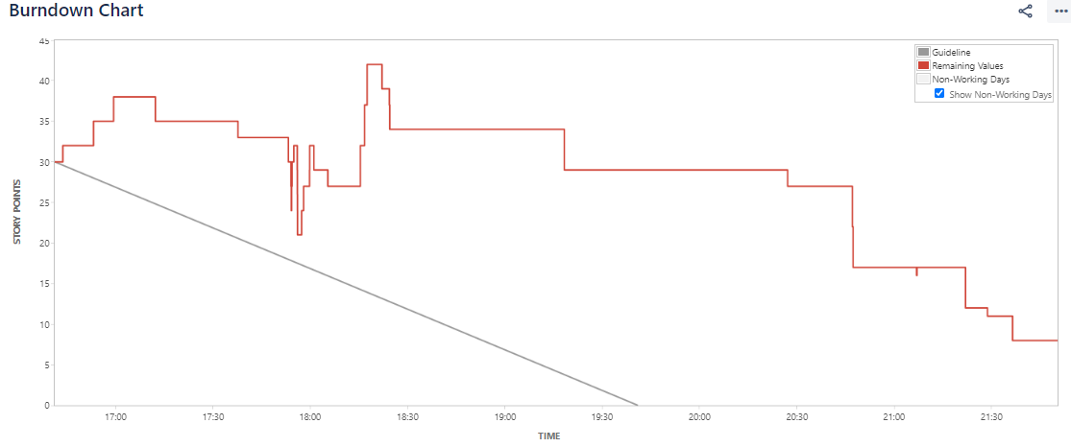

## **Sprint Burnup Chart**

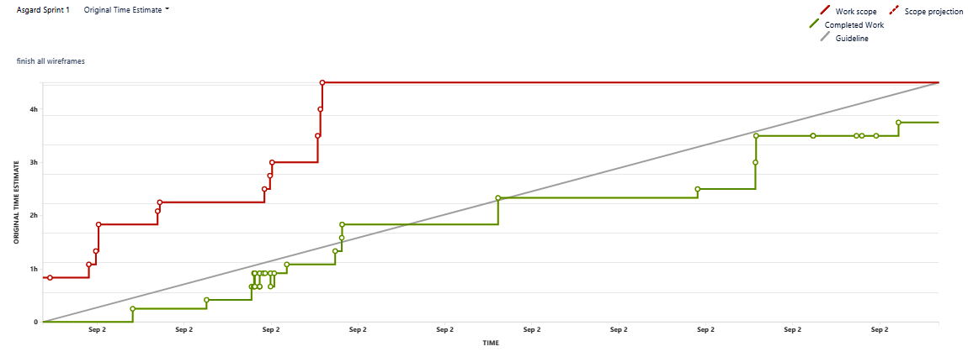

## **Product insights for improvement**

Used for product grooming

Improvement areas: Asgard Logo should be common for all the screen mockups